Java sort :
You are given a list of student information: ID, FirstName, and CGPA. Your task is to rearrange them according to their CGPA in decreasing order. If two student have the same CGPA, then arrange them according to their first name in alphabetical order. If those two students also have the same first name, then order them according to their ID. No two students have the same ID.
Hint: You can use comparators to sort a list of objects. See the oracle docs to learn about comparators.
Input Format
The first line of input contains an integer , representing the total number of students. The next lines contains a list of student information in the following structure:
ID Name CGPA
Constraints
The name contains only lowercase English letters. The contains only integer numbers without leading zeros. The CGPA will contain, at most, 2 digits after the decimal point.
Output Format
After rearranging the students according to the above rules, print the first name of each student on a separate line.
Sample Input
5
33 Rumpa 3.68
85 Ashis 3.85
56 Samiha 3.75
19 Samara 3.75
22 Fahim 3.76
Sample Output
Ashis
Fahim
Samara
Samiha
Rumpa
Program :
import java.util.*;

class Student {
int id;
String name;
double cgpa;

Student(int id, String name, double cgpa) {
this.id = id;
this.name = name;
this.cgpa = cgpa;
}
}

public class Main {
public static void main(String[] args) {
Scanner sc = new Scanner(System.in);

int n = sc.nextInt();
ArrayList<Student> students = new ArrayList<>();

for (int i = 0; i < n; i++) {
int id = sc.nextInt();
String name = sc.next();
double cgpa = sc.nextDouble();

students.add(new Student(id, name, cgpa));
}

Collections.sort(students, new Comparator<Student>() {
public int compare(Student a, Student b) {

// 1. CGPA decreasing
if (a.cgpa != b.cgpa) {
return Double.compare(b.cgpa, a.cgpa);
}

// 2. Name alphabetical
int nameCompare = a.name.compareTo(b.name);

if (nameCompare != 0) {
return nameCompare;
}

// 3. ID increasing
return Integer.compare(a.id, b.id);
}
});

for (Student s : students) {
System.out.println(s.name);
}
}
}
Output

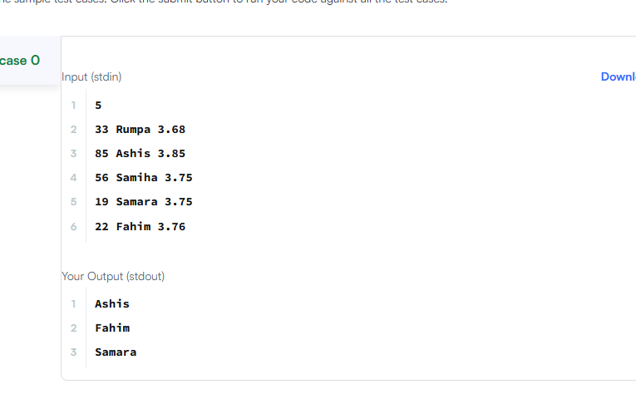

Sort array By Parity
Given an integer array nums, move all the even integers at the beginning of the array followed by all the odd integers.
Return any array that satisfies this condition.

Example 1:
Input: nums = [3,1,2,4]
Output: [2,4,3,1]
Explanation: The outputs [4,2,3,1], [2,4,1,3], and [4,2,1,3] would also be accepted.
Example 2:
Input: nums = [0]
Output: [0]

Constraints:
- 1 <= nums.length <= 5000
- 0 <= nums[i] <= 5000
Program
class Solution {
public:
vector<int> sortArrayByParity(vector<int>& nums) {
int left = 0;
int right = nums.size() - 1;

while (left < right) {
if (nums[left] % 2 > nums[right] % 2) {
swap(nums[left], nums[right]);
}

if (nums[left] % 2 == 0)
left++;

if (nums[right] % 2 == 1)
right--;
}

return nums;
}
};
Output :
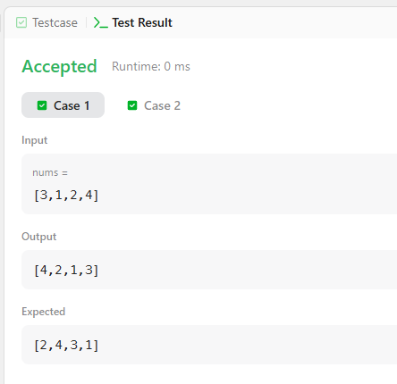

Comparators are used to compare two objects. In this challenge, you'll create a comparator and use it to sort an array. The Player class is provided in the editor below. It has two fields:
- : a string.
- : an integer.
Given an array of Player objects, write a comparator that sorts them in order of decreasing score. If or more players have the same score, sort those players alphabetically ascending by name. To do this, you must create a Checker class that implements the Comparator interface, then write an int compare(Player a, Player b) method implementing the Comparator.compare(T o1, T o2) method. In short, when sorting in ascending order, a comparator function returns if , if , and if .
Declare a Checker class that implements the comparator method as described. It should sort first descending by score, then ascending by name. The code stub reads the input, creates a list of Player objects, uses your method to sort the data, and prints it out properly.
Example
Sort the list as . Sort first descending by score, then ascending by name.
Input Format
The first line contains an integer, , the number of players.
Each of the next lines contains a player's and , a string and an integer.
Constraints

- Two or more players can have the same name.
- Player names consist of lowercase English alphabetic letters.
Output Format
You are not responsible for printing any output to stdout. Locked stub code in Solution will instantiate a Checker object, use it to sort the Player array, and print each sorted element.
Sample Input
5
amy 100
david 100
heraldo 50
aakansha 75
aleksa 150
Sample Output
aleksa 150
amy 100
david 100
aakansha 75
heraldo 50

Program :
import java.util.*;

class Player {
String name;
int score;

Player(String name, int score) {
this.name = name;
this.score = score;
}
}
class Checker implements Comparator<Player> {

public int compare(Player a, Player b) {
if (a.score != b.score) {
return b.score - a.score;
}

return a.name.compareTo(b.name);
}
}

public class Solution {

public static void main(String[] args) {
Scanner scan = new Scanner(System.in);
int n = scan.nextInt();

Player[] player = new Player[n];
Checker checker = new Checker();

for(int i = 0; i < n; i++){
player[i] = new Player(scan.next(), scan.nextInt());
}
scan.close();

Arrays.sort(player, checker);
for(int i = 0; i < player.length; i++){
System.out.printf("%s %s\n", player[i].name, player[i].score);
}
}
}
Output :
